# How to define a Continuous Axis Rotation with Fixture Builder?

This document build in 3 parts explained the way a Continuous Axis Rotation channel works within Fixture Builder of Realizzer 3D.

To have a better understanding, this document take the Contest fixture Heliptic where a continuous rotations exists.

## Step 1: Continuous Axis Rotation Channel Position

**Rule n°1:** The Continuous Axis Rotation Channel shall always be located after the axis where to apply the continuous rotation.

Contest Heliptic, in 20ch mode, has the Continuous X (PAN) Rotation at #1 and the standard X (PAN) rotation at #2

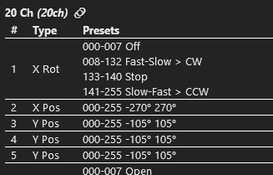  
Source: <https://fixturesfinder.com/fixture/Contest/Heliptic+9x10WH>

In Fixture Builder, apply the Rule n°1 by setting the Continuous X (PAN) Rotation after the standard X (PAN) rotation:

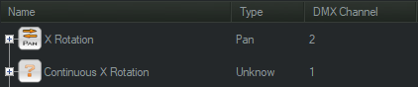  
DMX Charts with Continuous X Rotation set after the X Rotation

## Step 2: Set Presets on both channel

**Rule n°2:** Create, even non-typed, standard X (PAN) rotation preset for the standard X (PAN) rotation channel.

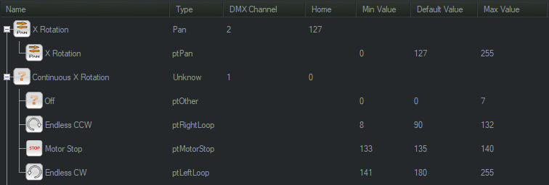  
The preset for standard X (PAN) rotation is essential for continuous rotation

## Step3: Set standard X (PAN) rotation working only under condition

**Rule n°3:** A fixture motor shall never be addressed more than once in a time

To respect the Rule n°3 you shall define conditions on the standard X (PAN) rotation to allow it to works only when there are no continuous X (PAN) rotation command launch.

In other words, the channel #2 shall be only active when the preset “Off” or “Motor Stop” are active on channel #1.

Conditions can only set on preset, this is why the Rule n°2 has to be fulfilled.

To set a condition on preset, select this last (X Rotation), and hit the “Conditions” button located on the right of the DMX Settings window (where you have defined the DMX Range of each preset)

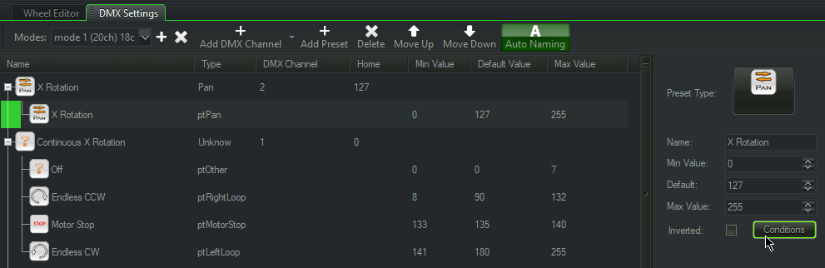  
Select Preset > Conditions button

The condition window appears.

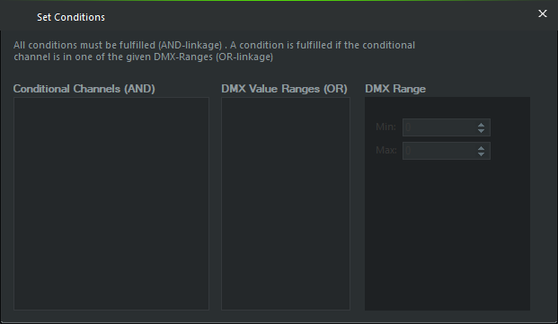  
Preset window condition

Right click inside the first fieldset (Conditional Channels) area to let you display a dropdown menu where you can select the channel which will be used for the condition

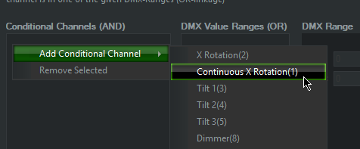  
Add Conditional Channel > Continuous X Rotation (#1)

Then, you can redo the same right click, but on the second fieldset (DMX Value Ranges) and select the presets where this preset shall be active (only). In our cases

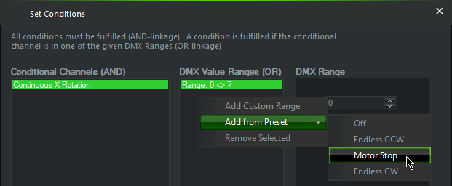  
DMX Value Ranges > Off + Motor Stop

Now you can see the final result of the condition:

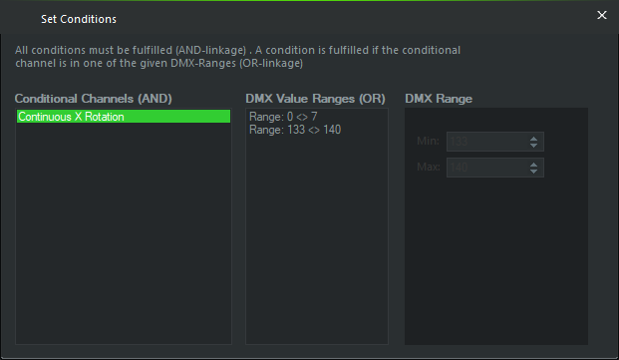

This condition can be translated with following sentence:

Apply the standard X (PAN) rotation when the channel #1 Continuous X Rotation is not active (from 0 to 7, or from 133 to 140 = no continuous rotation)

You can now close this window, save your fixture, and let give a try to see the continuous rotation working as you were expecting to.